

Attendance Management Plan
Approval: | Term 1, 2026 | Published on: | www.haurokovalley.school.nz
Effective date: | Term 1, 2026 | Review date: | Term 1, 2027

Attendance Objectives and Strategic Priorities
To raise student attendance by providing an environment where our students feel safe, valued, and that they belong. We know once student wellbeing is taken care of, and attendance is regular, we are able to focus on opportunities to learn. This provides a platform for each student to achieve their educational potential.
The government target is for 80% of students to be regularly attending school by 2030.
Our school currently has 75% regular attendance (for 2025) and a target of lifting regular attendance to 80% by the end of 2026.
Strategic Goal
#1 Build resilience and well-being at Hauroko Valley Primary School.
#2 Sustain high-quality reading, writing, and mathematics programmes to accelerate student progress and
achievement.
#3 Strengthen a responsive curriculum by designing rich opportunities and coherent pathways for all ākonga.

Refer to Hauroko Valley Everyday Matters Attendance Data

Whole School Regular Attendance
Term | 2020 | 2021 | 2022 | 2023 | 2024 | 2025
1 | n/a | 74% | 48% | 73% | 76% | 75%
2 | n/a | 68% | 47% | 44% | 76% | 68%
3 | 53% | 76% | 41% | 70% | 62% | 78%
4 | 24% | 80% | 63% | 48% | 69% | 77%
Av. | n/a | 75% | 50% | 59% | 71% | 75%

There are inconsistencies across Terms and Years with attendance data. Various reasons are included, however the most frequent is
- illness requiring students to remain at home while unwell
- families taking, in term overseas holidays.
There has been a focus on improving regular attendance, at Hauroko Valley Primary School, which has seen our data improve in the past few years.
We have achieved success with regular attendance data by reinforcing the importance of this for our children and families. This is included in the school newsletter, talked about in classes and recognised in assemblies – for end of term attendance achievements close to/or 100%. We address concerns as they present as per our STAR Framework. Home and School Partnership meetings are held to discuss ways to support regular attendance.

This Attendance Management Plan sets out Hauroko Valley Primary School’s approach to identifying and responding to student absences. The plan supports improved engagement, equity, and wellbeing for all students, and aligns with the Ministry of Education’s Stepped Attendance Response (STAR).

Attendance Roles & Responsibilities
Board  Responsibilities | The board is responsible for taking all reasonable steps to ensure that the school’s students attend the school when it is open for instruction. This covers Governance, Strategic Direction and Accountability.  The board will comply with the provisions in the legislation in relation to student attendance by:  - having a commitment to support students return to regular attendance.  - having processes and procedures in place to support a Stepped Attendance Response to student absence that uses data-based thresholds to identify students.  - receiving and reviewing regular reports from the Principal through Everyday Matters Data and through school-wide attendance data and trends.  - having an effective method in place for identifying and monitoring student absence, including identifying patterns and barriers to student attendance.  - setting an annual attendance target.  - overseeing the implementation of regular review of Hauroko Valley Primary School’s Attendance Management Plan (AMP) which is aligned with the STAR Framework.  - publishing this attendance management plan on the school’s website.
Principal  SENCO  Responsibilities | The Principal has responsibilities for Leadership and Strategy including Promoting and attendance culture and minimising disruptions to the school day. They manage the attendance concerns, interventions and actions. There is collaborative communication between internal and external agencies as required.  - management of additions to the school day, week and term to minimise unnecessary disruptions.  - communicate the importance of regular attendance (attending over 90% of the time) to students, parents and staff.  - developing and implementing a stepped attendance response aligned with the thresholds to support student attendance  - ensure that student absence is investigated, responded too and actions taken recorded aligned with the thresholds  - ensure all students, whanau and staff understand the processes and procedures that support student attendance  - ensure all staff (teachers, office staff, LSC) understand and fulfil their roles in accurate roll marking, early follow up on absences and implementing support strategies.  - ensure families receive clear information about attendance expectations at enrolment and throughout the year, and what stpes the school will take when a student is absent.  - approve or lead formal meetings with parents, students and where required external agencies (Attendance Services) to develop and implement support plans.  - Facilitate collaboration and information sharing with Ministry of Education, Attendance Services and other government or community agencies to address complex attendance barriers.  - report to the board on any trends, barriers to attendance and interventions being used to support student attendance
Teachers | - reinforce clear communication to parents and students on attendance expectations at the start of the year, weekly and each term  - communicate to parents what steps the school will take if the student is absent from school  - monitor student attendance  - provide students with regular updates on their own attendance  - report regularly to parents on attendance of their child.
Officer Administrator | - daily access to HERO Linc-Ed to manage morning and afternoon checklists as soon after 9.30am and 1.30pm.  - communicate with families to establish reasons for absences.  - maintain accurate records by coding absences as per the Ministry of Education guidelines.  - liaise with teaching staff.  - enter relievers’ rolls twice daily.
Caregivers | - ensure students attend every day they are able  - reinforce good attendance habits  - open communication with the school  - follow the school’s attendance management plan and associated attendance policies and procedures.
Learning Support Coordinator | - tracks attendance to monitor patterns over time.  - liaise with Principal, Classroom Teacher.  - at times liaise with families, as guided by the Principal.
Reliever | - accurately mark the attendance register via HERO Linc-Ed SMS hard copy by 9.30am and 1.30pm daily. Ensure this is delivered to the school office.

The principal will maintain reporting of daily attendance data.
The board will receive termly attendance reporting - including information provided by the Every Day Matters Term Reports. Included in this reporting will be any emerging trends, barriers to attendance, and areas of concern for the board's consideration.

Attendance Legislation
- Education and Training Act 2020
- Education Attendance Rules
- Education Attendance Management Plan regulations

Attendance Policies
- Attendance Procedures Policy
- Communicating with Parents and Whanau Policy
- Curriculum and Student Achievement Policy
- Student Management Policy
- Communications Policy
- Health Education Policy

Attendance Management Procedures
- Daily Monitoring (AM & PM)
- Teachers mark attendance in HERO Linc-Ed by 9:30am and again in the afternoon by 1:30pm.
- Late arrivals need to check in with the Administration Officer.
- Attendance Officer follows up on unexplained absences.
- Text sent to families for any unexplained absences: "Notification that ~PUPILNAME is marked absent without explanation today. Please contact the school as soon as possible to inform us of the reasons for ~PUPILNAME’s absence. Regards, Hauroko Valley Primary School”
- Follow-up phone call if no response within a reasonable time.
- If still no response, an email is sent.
- All communications and codes are recorded in HERO Linc-Ed. E.g: lateness
If a student is late six or more times in a term, a formal email is sent to families outlining the pattern of lateness, its impact on learning, and expectations for improvement.
- Monitoring practices include identifying barriers and patterns of concern.

The STAR framework clarifies that lifting attendance is a shared responsibility involves students, parents/caregivers, schools (including the Principal and Board) and the Ministry of Education.
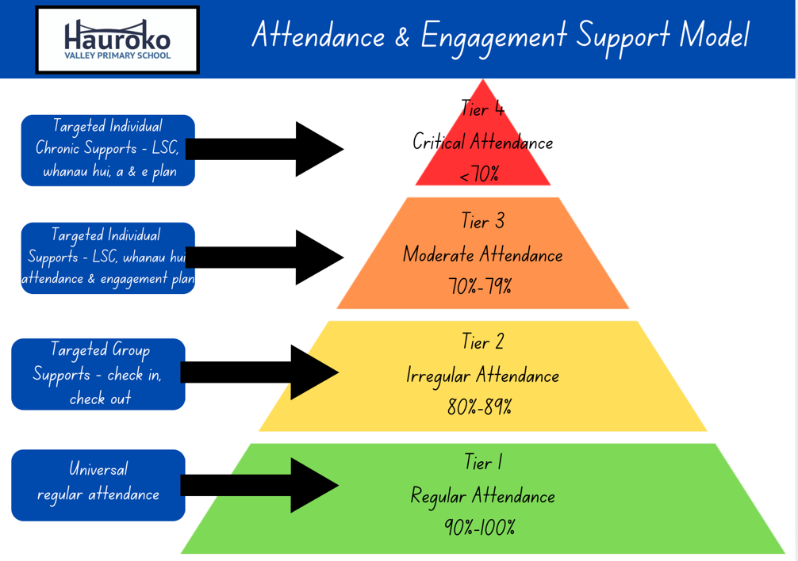
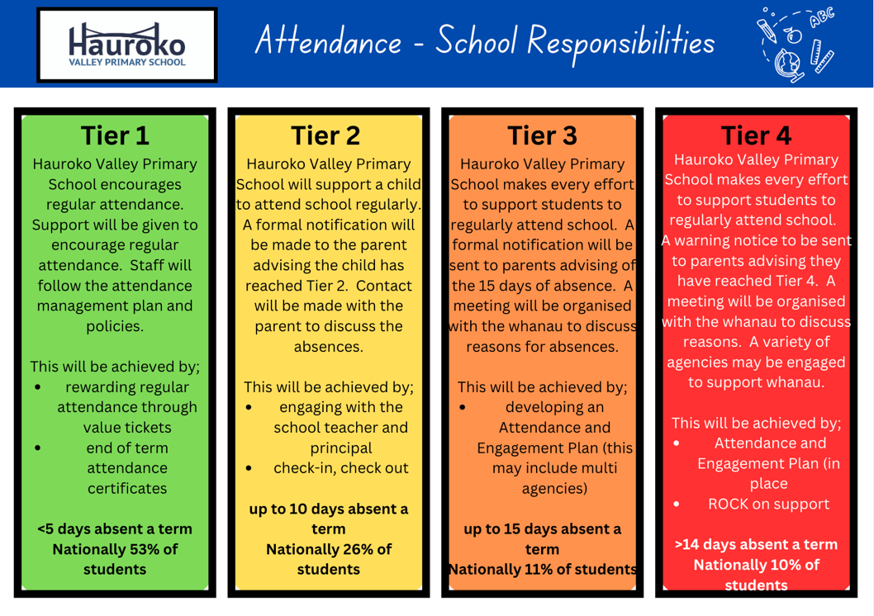
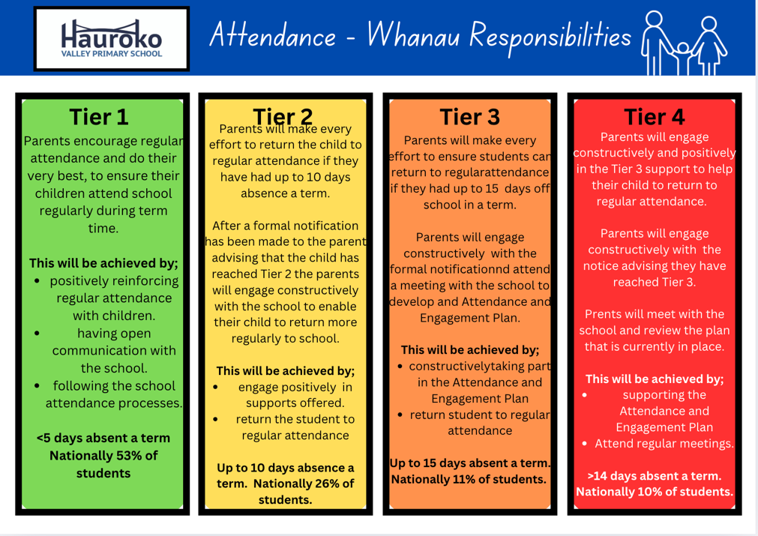
Reviewed: February 2026 Next Review: February 2027

