Hauroko Valley Governance Manual and Policy Framework

2019-2021

Policy Framework

The following documentation outlines the board’s governance framework and is aligned with the school’s Charter values. It supports a governance model that is hands off and strategic rather than hands on and operational. This framework operates on a triennial review programme.
Index:

Introduction 4

Part 1 - The Charter – Our number 1 policy 6

Part 2 - Governance Policies – The board’s rules for how it intends to govern 7

- Board Roles and Responsibilities Policy 7
- Responsibilities of the Principal Policy 9
- Disciplinary Process in Relation to the Principal Policy 9
- Principal Professional Expenses Policy 10
- Reporting to the Board Policy 10
- Trustees’ Code of Behaviour Policy 11
- Trustee Remuneration and Expenses Policy 11
- Conflict of Interest Policy 11
- Chair’s Role Description Policy 12
- Staff/Student Trustee Role Description Policy 12
- The Relationship between the Board and the Principal Policy 13
- Principal’s Performance Management Policy 13
- The Relationship Between the Chair and the Principal Policy 14
- Meeting Process Policy 15
- Meeting Procedure Policy 15
15.1 Public Attending Board Meetings Procedure 17
15.2 Meeting Agenda 18
15.3 Evaluation of meeting 19
- Board Induction Policy 19
- Board Review Policy 20
- Committee Policy 20
18.1 Review Committee Terms of Reference 21
18.2 Student Disciplinary Committee Terms of Reference 21
18.3 Finance Committee Terms of Reference 22
19. Hauroko Valley Primary School Delegations List 24
20. Concerns and Complaints Process 25
21. Trustee Register 26
22. Triennial Review Programme/Board Annual Work Plan 27

Part 3 - Operational Policies – The board’s expectations in areas it wishes to have some control over

- Curriculum Delivery Policy 30
- Personnel Policy 30
- Appointments Policy 30
- Financial Planning Policy 31
- Financial Condition Policy 31
- Asset Protection Policy 31
- Health and Safety Policy 32
- Legal Responsibilities Policy 32
Introduction

The Board of Trustees of Hauroko Valley Primary School is focused on the ongoing improvement of student progress and achievement within an environment that provides inclusive education.

Refer to the New Zealand Curriculum, the New Zealand Disability Strategy, and the United Nations Convention on the Rights of Disabled People.

To ensure effective school performance, the board is committed to maintaining a strong and effective governance framework that incorporates legislative requirements and good practice.

Governance and Management

The following are the board’s agreed governance and management definitions which form the basis upon which both the working relationships and the board’s policies are developed.

Governance | Management
The ongoing improvement of student progress and achievement is the board’s focus.  The board acts in a stewardship role and is entrusted to work on behalf of all stakeholders. It is accountable for the school’s performance, emphasises strategic leadership, sets the vision for the school and ensures compliance with legal and policy requirements.  Board policies are at a governance level and outline clear delegations to the principal. The board and principal form the leadership, with the role of each documented and understood. The principal reports to the board as a whole with committees used sparingly and only when a need is identified in order to contribute to board work.  The board is proactive rather than reactive in its operations and decision making and does not involve itself in the administrative details of the day to day running of the school. | The board delegates all authority and accountability for the day-to-day operational organisation of the school to the principal who must ensure compliance with both the board’s policy framework and the law of New Zealand. [For detail see Operational Policies]

In developing the above definitions for Hauroko Valley Primary School the board is mindful of the following excerpts from the Education Act 1989:

Education Act 1989, (Section 75, 72, 76, 65 and 66)

The Education Act 1989 was revised on 13th June 2013 to better reflect the board’s primary focus of student achievement. The legal and prime responsibility of boards of trustees is determined by Section 75 of the Education Act 1989:

s.75 Functions and powers of boards
(1) A school's board must perform its functions and exercise its powers in such a way as to ensure that every student at the school is able to attain his or her highest possible standard in educational achievement.
(2) Except to the extent that any enactment or the general law of New Zealand provides otherwise, a school's board has complete discretion to control the management of the school as it thinks fit.

s.72 Bylaws –
Subject to any enactment, the general law of New Zealand, and the school's charter, a school's board may make for the school any bylaws the board thinks necessary or desirable for the control and management of the school.

s.76 Principals –
(1) A school’s principal is the board’s chief executive in relation to the school’s control and management.
(2) Except to the extent that any enactment or the general law of New Zealand provides otherwise, the principal –
(a) Shall comply with the board’s general policy directions; and
(b) Subject to paragraph (a), has complete discretion to manage as the principal thinks fit the school’s day to day administration.

s.65 Staff
….A board may from time to time, in accordance with the State Sector Act 1988, appoint, suspend, or dismiss staff.

s66 Delegations
(1) The governing board of a board may delegate any of the functions or powers of the board or the governing board, either generally or specifically, to any of the following persons by resolution and written notice to the person or persons:
(a) a trustee or trustees:
(b) the principal or any other employee or employees, or office holder or holders, of the board:
(c) a committee consisting of at least 2 persons, at least 1 of whom is a trustee:
(d) any other person or persons approved by the board's responsible Minister:
(e) any class of persons comprised of any of the persons listed in paragraphs (a) to (d).

In order to carry out effective governance of the school the board has developed the following policy framework:

Part 1 The Charter

See attached.
Part 2 Governance Policy

These governance policies outline how the board will operate and set standards and performance expectations that create the basis for the board to monitor and evaluate performance as part of its ongoing monitoring and review cycle. (See 3 year review programme).

1. Board Roles and Responsibilities Policy

The board of trustees’ key areas of contribution are focused on four outcome areas:

Representation
Leadership
Accountability
Employer Role

The board | The Standards
1. Sets the strategic direction and long-term plans and monitors the board’s progress against them | 1.1 The board leads the annual charter review process  1.2 The board sets/reviews the strategic aims in line with MOE expectations  1.3 The board approves the annual plan and targets and ensures the Charter is submitted to the Ministry of Education (MoE) by 1 March each year  1.4 Regular board meetings include a report on progress towards achieving strategic aims  1.5 The Charter is the basis for all board decision making
2. Monitors and evaluates student progress and achievement | 2.1 The board approves an annual review schedule covering curriculum and student progress and achievement reports  2.2 Reports at each regular board meeting, from principal, on progress against annual plan, highlight risk/success  2.3 Targets in the annual plan are met, the curriculum policy is implemented and there is satisfactory performance of curriculum priorities
3. Protects the special character of the school (Special character schools) | 3.1 Special character is obviously considered in all board decisions  3.2 Special character report is included at every board meeting as part of the principal’s report
4. Appoints, assesses the performance of and supports the principal | 4.1 Principal’s performance management system in place and implemented
5. Approves the budget and monitors financial management of the school | 5.1 Budget approved by the first meeting each year  5.2 Satisfactory performance of school against budget
6. Effectively manages risk | 6.1 The board has an effective governance model in place  6.2 The board remains briefed on internal/external risk environments and takes action where necessary  6.3 The board identifies 'trouble spots' in statements of audit and takes action if necessary  6.3 The board ensures the principal reports on all potential and real risks when appropriate and takes appropriate action
7. Ensures compliance with legal requirements | 7.1 New members have read and understood the governance framework including policies, the school charter, board induction pack and requirements and expectations of board members  7.2 New and continuing members have kept aware of any changes in legal and reporting requirements for the school. Board has sought appropriate advice when necessary  7.3 Accurate minutes of all board meetings, approved by board and signed by chair  7.4 Individual staff/student matters are always discussed in public excluded session  7.5 Board meetings have a quorum
8. Ensures trustees attend board meetings and take an active role | 8.1 Board meetings are effectively run  8.2 Trustees attend board meetings having read board papers and reports and are ready to discuss them  8.3 Attendance at 80% of meetings (min.)  8.4 No unexplained absences at board meetings (3 consecutive absences without prior leave result in immediate step down) Refer Education Act 1989, s104 (1) (c)
9. Approves major policies and programme initiatives | 9.1 Approve programme initiatives as per policies  9.2 The board monitors implementation of programme initiatives
10. Fulfils the intent of the Treaty of Waitangi by valuing and reflecting New Zealand’s dual cultural heritage | 10.1 The Treaty of Waitangi is obviously considered in board decisions  10.2 The board, principal and staff are culturally responsive and inclusive
11. Approves and monitors human resource policy/procedures which ensures effective practice and contribute to its responsibilities as a good employer | 11.1 Becomes and remains familiar with the broad employment conditions which cover employees (i.e. Staff employment agreements and arrangements)  11.2 Ensures there are personnel policies in place and that they are adhered to e.g. Code of Conduct  11.3 Ensures there is ongoing monitoring and review of all personnel policies
12. Deals with disputes and conflicts referred to the board as per the school’s concerns and complaints procedures | 12.1 Successful resolution of any disputes and conflicts referred
13. Represents the school in a positive, professional manner | 13.1 Code of behaviour adhered to
14. Oversees, conserves and enhances the resource base | 14.1 Property/resources meet the needs of the student achievement aims
15. Effectively hands over governance to new board/trustees at election time | 15.1 New trustees provided with governance manual and induction  15.2 New trustees fully briefed and able to participate following attendance at an orientation programme  15.3 Appropriate delegations are in place as per s66 Education Act  15.3 Board and trustees participate in appropriate professional development
Review schedule: Triennially
2. Responsibilities of the Principal Policy

The principal is the professional leader of the school and the board’s chief executive working in partnership with the board of trustees. The principal shall not cause or allow any practice, activity or decision that is unethical, unlawful, and imprudent or which violates the board’s Charter or expressed values or commonly held professional ethic.

Alongside their professional role, the principal’s key contribution to day-to-day management of the school is as per the management definition in the introduction to this governance manual.

The principal is responsible for overseeing the implementation of board policy including the Charter. Reference in documentation to the school, management and staff is to be read as “principal” for responsibility for implementation. From time to time the chair of the board acting within delegated authority may issue discretions in policies of the school, in minutes of the board, or by written delegation.

The responsibilities of the principal are to:

- Meet the requirements of the current job description
- Meet the requirements of their employment agreement including the 4 areas of practice from the Principals’ Professional Standards
- Act as the educational leader and day to day manager of the school within the law and in line with all board policies
- Participate in the development and implementation of their annual performance agreement, and participate in their annual review process
- Develop, seek board approval of, and implement an annual plan that is aligned with the board’s strategic plan, meets legislative requirements and gives priority to improved student progress and achievement.
- Use resources efficiently and effectively and preserve assets (financial and property).
- Put good employer policies into effect and ensure there are effective procedures/guidelines in place.
- Allocate pay units for appropriate positions.
- Ensure effective and robust performance management systems are in place for all staff which include performance management reviews, attestations for salary increases and staff professional development
- Employ, deploy and terminate relieving and non-teaching staff positions.
- Employ teaching staff as per the appointments policy.
- Communicate with the community on operational matters where appropriate.
- Refrain from unauthorised public statements about the official position of the board on controversial social, political, and/or educational issues
- Keep the board informed of information important to its role.
- Report to the board as per the boards reporting policy requirements.
- Act as Protected Disclosures Officer and ensure procedures are in place to meet the requirements of the Protected Disclosures Act 2000
- Appoint, on behalf of the board, the Privacy Officer and EEO Officer.

Only decisions made by the board acting as a board are binding on the principal unless specific delegations are in place. Decisions or instructions by individual board members, committee chairs, or committees are not binding on the principal except in rare circumstances when the board has specifically authorised it.

The relationship is one of trust and support with expectations documented in the relationship policy. All parties work to ensure “no-surprises”.

The principal is not restricted from using the expert knowledge of individual board members acting as community experts.

Review schedule: Triennially

3. Disciplinary Process in Relation to the Principal Policy

In the event the board receives a complaint regarding the principal or determines that policy violation(s) may have occurred in the first instance the board will consider whether this may be dealt with in an informal manner (as per the employment agreement provisions that apply to the principal). Where the board considers the degree and seriousness of the concern or violation(s) sufficient to warrant initiating a disciplinary or competency process, the board shall seek the support and advice in the first instance from an NZSTA adviser to ensure due process is followed.

Review schedule: Triennially

4. Principal Professional Expenses Policy

A budget for professional expenses and for professional development will be established annually in accordance with the principal’s professional development plan contained in their performance agreement and be included in the budget. Spending within budget is with the approval of the board. Any overseas trips for professional development must be approved by the board of trustees at least one term in advance of the event.

Professional development expenses may include but are not confined to: continuing education, books and periodicals, mentoring, and attendance at professional conferences.

Review schedule: Triennially

5. Reporting to the Board Policy

The principal reports to the board as a whole and keeps it informed of the true and accurate position of the outcomes of curriculum; teaching and learning; financial position; and all matters having real or potential legal considerations and risk for our school. Thus the board is supported in its strategic decision-making and risk management by also requiring the principal to submit any monitoring data required in a timely, accurate and understandable fashion. Therefore, the principal must ensure that they:

- Inform the board of significant trends, implications of board decisions, issues arising from policy matters or changes in the basic assumptions upon which the board’s strategic aims are based.
- submit written reports covering the following management areas for each board meeting:
  - principal’s management report including:
    - Strategic Aim Report
    - Personnel Report
    - Finance Report
    - Variance Report
    - Key Performance Indicators
and,
  - the coordination and approval of the following reports:
    - Student Progress and Achievement Report
    - Curriculum Report
- inform the board in a timely manner of any significant changes in staffing, programmes, plans or processes that are under consideration
- submit any monitoring data required in a timely, accurate and understandable fashion
- report and explain financial variance against budget in line with the board’s expectations
- report on the number of stand-downs, suspensions, exclusions and expulsions on a per meeting basis
- report and explain roll variance against year levels and reasons on a per meeting basis
- present information in a suitable form – not too complex or lengthy
- inform the board when, for any reason, there is non-compliance of a board policy
- recommend changes in board policies when the need for them becomes known
- highlight areas of possible bad publicity or community dis-satisfaction
- coordinate management/staff reports to the board and present to the board under the principal’s authority
- regularly report on the implementation of the annual plan and progress towards meeting student achievement targets
- report on any matter requested by the board and within the specified timeframe

Review schedule: Triennially

6. Trustees’ Code of Behaviour Policy

The board is committed to ethical conduct in all areas of its responsibilities and authority. Trustees shall:

- Maintain and understand the values and goals of the school
- Protect the special character of the school
- Ensure the needs of all students and their achievement is paramount
- Be loyal to the school and its mission
- Publicly represent the school in a positive manner
- Respect the integrity of the principal and staff
- Observe the confidentiality of non-public information acquired in their role as a trustee and not disclose to any other persons such information that might be harmful to the school
- Be diligent and attend board meetings prepared for full and appropriate participation in decision making
- Ensure that individual trustees do not act independently of the board’s decisions
- Speak with one voice through its adopted policies and ensure that any disagreements with the board’s stance are resolved within the board
- Avoid any conflicts of interest with respect to their fiduciary responsibility
- Recognise the lack of authority in any individual trustee or committee/working party of the board in any interaction with the principal or staff
- Recognise that only the chair (working within the board’s agreed chair role description or delegation) or a delegate working under written delegation, can speak for the board
- Continually self-monitor their individual performance as trustees against policies and any other current board evaluation tools
- Be available to undertake appropriate professional development

I, ______________________ have read and understood this Code of Behaviour Policy and agree to follow and abide by it to the best of my ability.

Signature:

Date:

Review schedule: Triennially

7. Trustee Remuneration and Expenses Policy

The board has the right to set the amount that the chair and other board members are reimbursed for attendance at board meetings in recognition that these fees cover the expense of attending board meetings. The principal, as a member of the board is entitled to the same payment as all other trustees except the chair. Currently at Hauroko Valley Primary school;

1 The chair receives $75.00 per board meeting
2 Elected board members receive $55.00 per board meetings
3 There is no payment for working group/committee meetings
4 Attendance fees are non-taxable within the agreed non-taxable amounts of $605 annually for trustees and $825 for the chair
5 Attendance costs for professional development sessions will be met by the board of trustees. Prior approval must first be sought
6 All other reimbursements are at the discretion of the board and must be approved prior to any spending occurring

Review schedule: Triennially

- Conflict of Interest Policy
The standard of behaviour expected at Hauroko Valley Primary School is that all staff and board members effectively manage conflicts of interest between the interests of the school on one hand, and personal, professional, and business interests on the other. This includes managing potential and actual conflicts of interest, as well as perceptions of conflicts of interest.

The purposes of this policy are to protect the integrity of the school decision-making process, to ensure confidence in the school’s ability to protect the integrity and reputations of board members and meet legislative requirements. Upon or before election or appointment, each person will make a full, written disclosure of interests, relationships, and holdings that could potentially result in a conflict of interest. This written disclosure will be kept on file and will be updated as appropriate.

In the course of board meetings, board members will disclose any interests in a transaction or decision where their family, and/or partner, employer, or close associates will receive a benefit or gain. After disclosure, the person making the disclosure will be asked to leave the meeting for the discussion and will not be permitted to vote on the question.

Review schedule: Triennially

- Chair’s Role Description Policy
The chair of Hauroko Valley Primary School safeguards the integrity of the board’s processes and represents the board of trustees to the broader community. The chair ensures that each trustee has a full and fair opportunity to be heard and understood by the other members of the board in order that collective opinion can be developed and a board decision reached. The board’s ability to meet its obligations and the plans and targets it has set are enhanced by the leadership and guidance provided by the chair.

The Chair:
- Is elected at the first board meeting of the year except in a triennial trustee election year where it shall be at the first meeting of the board*
- Welcomes new members, ensures that the conflict of interest disclosure is made and the code of behaviour is understood and signed, and leads new trustee induction
- Assists board members' understanding of their role, responsibilities and accountability including the need to comply with the Trustees’ Code of Behaviour policy
- Leads the board members and develops them as a cohesive and effective team
- Ensures the work of the board is completed
- Ensures they act within board policy and delegations at all times and do not act independently of the board
- Sets the board's agenda and ensures that all board members have the required information for informed discussion of the agenda items
- Ensures the meeting agenda content is only about those issues which according to board policy clearly belong to the board to decide
- Effectively organises and presides over board meetings ensuring that such meetings are conducted in accordance with the Education Act 1989, the relevant sections of the Local Government Official Information and Meetings Act 1987 and any relevant board policies*
- Ensures interactive participation by all board members
- Represents the board to external parties as an official spokesperson for the school except for those matters where this has been delegated to another person/s and is the official signatory for the annual accounts*
- Is responsible for promoting effective communication between the board and wider community including communicating appropriate board decisions
- Establishes and maintains a productive working relationship with the principal
- Ensures the principal’s performance agreement and review are completed on an annual basis
- Ensures concerns and complaints are dealt with according to the school’s concerns and complaints procedures
- Ensures any potential or real risk to the school or its name is communicated to the board. This includes any concern or complaint

* Legislative Requirement

Review Schedule: Annually in November or prior to meeting when chair is elected

10. Staff/Student Trustee Role Description Policy
The staff/student trustee fulfils legislative requirements relating to board composition. The role of the staff/student trustee is to bring a staff/student perspective to board decision making and discussion.

As a trustee the staff/student trustee has an obligation to serve the broader interests of the school and its students and has equal voice, vote, standing and accountabilities as all other trustees.

Staff/Student Trustee accountability measure | Standard
1. To work within the board’s Charter | 1.1 The Charter is obviously considered in board decisions
2. To abide by the board’s governance and operational policies | 2.1 The staff/student trustee has a copy of the Governance Manual and is familiar with all board policies
3. The staff/student trustee is first and foremost a trustee and must act in the best interests of the students at the school at all times. | 3.1 The staff/student trustee is not a staff/student advocate  3.2 The staff/student trustee does not bring staff/student concerns to the board
4. The staff/student trustee is bound by the Trustee Code of Behaviour | 4.1 The staff/student trustee acts within the code of behaviour
5. It is not necessary for the staff/student trustee to prepare a verbal or written report for the board unless specifically requested to from the board | 5.1 No regular reports received unless a request has been made by the board on a specific topic.

Review schedule: Triennially

11. The Relationship between the Board and the Principal Policy

The performance of the school depends significantly on the effectiveness of this relationship and as such a positive, productive working relationship must be developed and maintained. The board and the principal form the leadership team and as such clear role definitions have been developed. The Responsibilities of the Principal and Responsibilities of the Board policies along with the board’s agreed Code of Behaviour should be read alongside this policy.

- This relationship is based on mutual respect, trust, integrity and ability.
- The relationship must be professional.
- The principal reports to the board as a whole rather than to individual trustees.
- Day to day relationships between the board and the principal are delegated to the chair.
- All reports presented to the board by the staff (unless specifically requested by the board) arrive there with the principal’s approval and the principal is accountable for the contents.
- There are clear delegations and accountabilities by the board to the principal through policy.
- The two must work as a team and there should be no surprises.
- Neither party will deliberately hold back important information.
- Neither party will knowingly misinform the other.
- The board must maintain a healthy independence from the principal in order to fulfil its role. The board is there to critique and challenge the information that comes to it, acting in the best interests of students at the school.
- The principal should be able to share their biggest concerns with the board.

Review schedule: Annually

12. Principal’s Performance Management Policy

It is the policy of the Hauroko Valley Primary School Board of Trustees to establish a performance agreement with the principal each year* and review the principal’s performance on an annual basis with the objective of ensuring that every student at the school is able to attain his or her highest possible standard in educational achievement.

- The review process will occur annually, providing a written record of how the principal has performed as per the terms of the performance agreement and identifying professional development needs.
- The principal’s performance will be formally reviewed on an annual basis by duly delegated member(s) of the boards and optionally, at the board’s choice, an independent consultant who specialises in education.
- Those delegated or contracted to perform the review process shall have written formalised instructions specifying the responsibilities of the role.
- There will be three interim reviews, one per each term preceding the annual formal review, between the principal and chair or delegate(s) to discuss progress.
- The principal will be reviewed on the criteria set forth in the performance agreement: performance objectives, professional standards, learning and development objectives and fulfilment of additional duties which require concurrence payment.
- If the principal and the board disagree on the performance objectives, the board, after considering the principal’s input, will amend the disputed objectives or confirm the unchanged objectives. The board’s decision will be final.
- The board chair, delegate(s) and consultant may gather information from staff, parents, or any other relevant members of the larger school community who can provide feedback on how the principal has performed. Evidence may include surveys, self-review, teaching observation (if relevant), interviews, focus groups or documentary evidence.
- The principal and delegate(s) will meet for a formal interview to discuss whether the performance agreement has been satisfied with the principal given the opportunity to discuss and comment on each criterion before a rating is given. The results will then be drafted into a report by the delegate(s) and sent to the principal. The principal can accept the report or dispute the report. If the report is disputed, the delegate(s) will consider the principal’s views before deciding to either amend the report, in accordance with the principal’s views, or let the report stand, with the principal’s comments attached.
- The chair/delegate(s)/consultant will present the final report/summary back to the board the result of the review. The principal may/may not be present at the presentation and/but will have the opportunity to address the board. The principal will then exit and further discussion may continue among the board.
- The principal will be informed personally and in writing of the final outcome following the report discussion.
- The performance agreement and results of the review are confidential to the principal, the board and their agents unless both parties agree to wider distribution.

* Legal requirement

Signature

I, __________________________________, have been informed of the performance review policy and procedures of Hauroko Valley Primary School Board.

Signature___________________________________Date___________________________

Review schedule: Triennially

13. The Relationship between the Chair and the Principal Policy

The chair is the leader of the board and works on behalf of the board on a day to day basis with the principal.

The relationship principles are to be read in line with the following:
- The board’s agreed governance and management definitions
- The board’s Roles and Responsibilities Policy
- The Responsibilities of the Principal Policy
- The Chair’s Role Description Policy
- The Trustees’ Code of Behaviour Policy

Relationship principles:

- A positive, productive working relationship between the principal and the chair is both central and vital to the school.
- This relationship is based on mutual trust and respect.
- The two must work as a team and there should be no surprises.
- The relationship must be professional.
- Each must be able to counsel the other on performance concerns.
- The chair supports the principal and vice versa when required and appropriate.
- There is understanding/acceptance of each other’s strengths and weaknesses.
- Each agree not to undermine the other’s authority.
- There is agreement to be honest with each other.
- Each agree and accept the need to follow policy and procedures.
- Agree not to hold back relevant information.
- Agree and understand the chair has no authority except that granted by the board.
- Understand that the chair and principal should act as sounding boards, both supporting and challenging in order to hold the school to account for achieving the goals and targets that have been set.

Review schedule: Annually

14. Meeting Process Policy

The board is committed to effective and efficient meetings that are focused at a governance level and provide the information the board needs to be assured that all policies, plans and processes are being implemented and progressing as planned. Meetings:

- Are based on a prepared annual agenda. The agenda preparation is the responsibility of the chair. Sufficient copies of the agenda of the open (public) session will be posted on the board of trustees’ notice board and available at the meeting place for the public.
- Are held with the expectation that trustees have prepared for them and will participate in all discussions at all times within the principles of acceptable behaviour.
- Have the right, by resolution, to exclude the public and news media from the whole or part of the proceedings in accordance with the Local Government Official Information and Meetings Act. Decisions by the board are fully recorded but remain confidential. The board needs to:
- make the reasons for excluding the public clear
- reserve the right to include any non-board member it chooses
- Can be held via audio, audio and visual, or electronic communication providing:
- all trustees who wish to participate in the meeting have access to the technology needed to participate, and
- a quorum of members can simultaneously communicate with each other throughout the meeting.

Review schedule: Triennially

15. Meeting Procedure Policy
(an * denotes legislative requirement)

Members of the school community are encouraged to take an active interest in the school and its performance and are welcome to attend all board meetings within the Public Attending Board Meetings Procedure (See p. 12).

Board meetings;

General:
- Meetings are held as per the triennial review schedule with dates confirmed each December for the following year.
- Board minutes will be taken by a non trustee paid on a commercial basis on contract.
- The quorum shall be more than half the members of the board currently holding office.*
- Only apologies received from those who cannot be present must be recorded. Trustees who miss three consecutive meetings without the prior leave of the board cease to be members. An apology does not meet the requirement of prior leave. To obtain prior leave a trustee must request leave from the board at a board meeting and the board must make a decision.*
- The chair shall be elected at the first meeting of the year except in the general election year where it will be at the first meeting of the newly elected board.*
- The chair may exercise a casting vote in the case of equality of votes, in addition to his/her deliberative vote.*
- Any trustees with a conflict or pecuniary interest in any issue shall not take part in any debate on such issues and may be asked to leave the meeting for the duration of the debate.* A pecuniary interest arises when a trustee may be financially advantaged or disadvantaged as a result of decisions made by the board. E.g. Contracts, pay and conditions etc. A conflict of interest is when an individual trustee could have, or could be thought to have, a personal stake in matters to be considered by the board.
- Only trustees have automatic speaking rights.
- The board delegates [and minutes] powers under Sections 15 and 17 of Education Act to the Disciplinary Committee.
- The board delegates [and minutes] authority to the deputy principal in the times of absence of the principal.
- The amount the chair and other board members are paid for attendance at board meetings is set by the board. Currently the chair receives $75 per board meeting and board members receive $55 per board meeting. There is no payment for committee or working party meetings.
- Attendance fees are non-taxable within the agreed non-taxable amounts of $605 annually for trustees and $825 for the chair.

Time of meetings:
- Regular meetings commence at 7pm and conclude by 10pm.
- A resolution for an extension of time may be moved but will not normally exceed 30 minutes.
- Any business remaining on the agenda at the conclusion of the meeting is transferred to the following meeting.

Special meetings:
- A special meeting may be called by delivery of notice to the chair signed by at least one third of trustees currently holding office.

Exclusion of the public:
- The meeting may, by resolution, exclude the public (going into committee) and news media from the whole or part of the proceedings in accordance with the Local Government Official Information and Meetings Act unless specifically asked to stay. The wording to be used in the motion to exclude the public is found in Schedule 2A of that Act. Excluding the public is most often used to ensure privacy of individuals or financially sensitive issues.*

Public participation:
- The board meeting is a meeting held in public rather than a public meeting.
- Public participation is at the discretion of the board.
- Public attending the meeting are given a notice about their rights regarding attendance at the meeting. Public Attending Board Meetings Procedure (See p. 12).

Motions/amendments:
- A motion is a formal proposal for consideration. All motions and amendments moved in debate must be seconded unless moved by the chair and are then open for discussion.
- Motions and amendments once proposed and accepted may not be withdrawn without the consent of the meeting
- No further amendments may be accepted until the first one is disposed of
- The mover of a motion has right of reply
- A matter already discussed may not be reintroduced at the same meeting in any guise or by way of an amendment

Tabling documents
- When written information is used in support of a discussion, it should be tabled so that it can be examined by those present. It then forms part of the official record.

Correspondence
- The board should have access to all correspondence. Correspondence that requires the board to take some action should be photocopied/scanned and distributed prior to the meeting. Other correspondence can be listed and tabled so that trustees can read it if required.

Termination of debate:
- All decisions are to be taken by open voting by all trustees present.

Lying on the table
- When a matter cannot be resolved, or when further information is necessary before a decision can be made, the matter can be left unresolved for future discussion.

Points of order
- Points of order are questions directed to the chair which require an answer or a ruling. They are not open to debate and usually relate to the rules for the running of a meeting.

Suspension of meeting procedures:
- The board’s normal meeting procedures may be suspended by resolution of the meeting.

Agenda:
- Agenda items are to be notified to the chair 7 days prior to the meeting
- Late items will only be accepted with the approval of the board and in rare circumstances where a decision is urgent
- The order of the agenda may be varied by resolution at the meeting.
- All matters requiring a decision of the board are to be agended as separate meeting items.
- All items in the agenda are to carry a recommended course of action and where appropriate be supplemented by supporting material in the agended documentation.
- The agenda is to be collated with the agenda items placed in the agenda order and marked with the agenda number.
- Papers requiring reading and consideration will not normally be accepted if tabled at the meeting.
- Papers and reports are to be sent to the board 5 working days before the meeting

Minutes
- The principal is to ensure that secretarial services are provided to the board.
- The minutes are to clearly show resolutions and action points and who is to complete the action.
- A draft set of minutes is to be completed and sent to the chair for approval within 3 working days of the board meeting before being distributed to trustees within 5 working days of the meeting.

Review schedule: Triennially

15.1 Public Attending Board Meetings Procedure

The board of trustees welcomes public presence at board meetings and hopes that members of the public enjoy their time observing board meetings.

In order that members of the public understand the rules that apply to then attending board meetings these procedures will be provided and followed unless otherwise authorised by the board.

- Board meetings are not public meetings but meetings held in public.
- If the meeting moves to exclude the public (usually this is to protect the privacy of individuals) then you will be asked to leave the meeting until this aspect of business has been concluded.
- Members of the public may request speaking rights on a particular subject that is on the agenda. Preferably this request has been made in advance. Public participation is at the discretion of the board.
- Speakers shall be restricted to a maximum of 3 minutes each per subject, with a time limit of fifteen minutes per interest group.
- No more than five speakers on any one topic.
- Speakers are not to question the board and must speak to the topic.
- Board members will not address questions or statements to speakers.
- Speakers shall not be disrespectful, offensive, or make malicious statements or claims.
- If the chair believes that any of these have occurred or the speaker has gone over time they will be asked to finish.

Please note: Members of the public include staff, students and parents of the school who are not trustees on the board.

Review schedule: Triennially

15.2 Meeting Agenda

A typical agenda will be as follows.

Board of Trustees Meeting Agenda – date

 | Policy Reference: | Led by: | Time:
- Administration
  - Present
  - Apologies
  - Declaration of interests
2. Decisions  2.1 Strategic decisions made if required | Policy Reference
3. Discussions
3.1 Ongoing summary of progress to date in relation to annual plan
3.2 Exploration of special issue or project e.g. budget, principal performance agreement/appraisal, delegations
4. Monitoring
4.1 Board discussion
4.2 Expert presentation
4.3 Data analysis
4.4 Exploration of key result area eg goals
4.5 Finance and Audit Report
5. Identify Agenda Items for Next Meeting

6. Administration
6.1 Confirmation of minutes
6.2 Correspondence
7. Meeting Closure
7.1 Comments on meeting procedures and outcomes
7.2 Preparation for next meeting
Note 1: Correspondence is listed on the back of the agenda
Note 2: List of current delegations attached to agenda

Review schedule: Triennially
15.3 Evaluation of meeting on [date] chaired by [name]

- How well did we accomplish the results we expected from this meeting based on the set agenda?

Not at all Very well
1 2 3 4 5

Comment:

- How satisfied are you with how the team worked as a group?
Not at all Very well
1 2 3 4 5

Comment:

- How satisfied are you with your participation and contribution as an individual?

Not at all Very well
1 2 3 4 5

Comment:

- Is there anything that you believe would improve our meeting process?

Name: (Optional)…………………………………………………………………………………………….

Review schedule: Triennially

16. Board Induction Policy
The board is committed to ensuring continuity of business and a smooth transition when trustees join the board. Therefore,
- New trustees will receive a welcome letter on their joining the board which includes:
- Where and when they can pick up their governance folder
- The suggested date of the induction
- The date of the next board meeting
- Chair and principal contact details
2. New trustees will be issued with a governance manual containing copies of the school’s:
- Charter – including the strategic and annual/operational plans
- Policies
- The current budget
- The last ERO report
- The last annual report
- The triennial review programme
- Any other relevant material
3. The chair or delegate will meet with new board members to explain board policy and other material in the governance manual.
4. The principal and chair or delegate, will brief all new members on the organisational structure of the school.
5. The principal will conduct a site visit of the school.
6. New board members are to be advised of the professional development that is available from NZSTA and other relevant providers.
7. After three months on the board, the effectiveness of the induction process is to be reviewed by the chair with the new members. The review will include the following aspects:

- Did you feel welcomed onto the board?
Very welcome Welcome Not very welcome
Comment:

- Did you receive all necessary information in a timely manner?
Very timely Timely Not very timely
Comment:

- Did you find the induction with principal and board chair to be effective?
Very effective Effective Not very effective
Comment:

Please comment on how we could improve this induction process:

- Board Review Policy
The performance of the board is measured by the outcomes from;
- the annual report
- the triennial review programme
- the Education Review Office (ERO) report
- any other means deemed appropriate by the board

Review schedule: Triennially

18. Committee Policy
The board may set up committees/working parties to assist the board carry out its responsibilities and due process (e.g., staff appointments, finance, property, disciplinary).

Education Act 1989, section 66

Section 66 gives the board the authority to delegate any of its powers to a special committee, except the power to borrow money. Refer to Section 66 for further information.

Board committees:
- Are to be used sparingly to preserve the board functioning as a whole when other methods have been deemed inadequate.
- Can consist of non-trustees. Committees must have a minimum number of 2 persons, at least one of whom must be a trustee.
- May not speak or act for the board except when formally given such authority for specific and time-limited purposes. Such authority will be carefully stated in order not to conflict with authority delegated to the principal or the chair.
- Help the board (not the staff) do its work.
- Other than the board discipline committee must act through the board and therefore can only recommend courses of action to the board and have no authority to act without the delegated authority of the board.
- Assist the board chiefly by preparing policy alternatives and implications for board deliberation. Board committees are not to be created by the board to advise staff.
- Are to have terms of reference drawn up as required. It is suggested that these contain information about the following:
- purpose
- committee members
- delegated authority

The following committees are currently established:

Review schedule: Triennially
Committee Terms of Reference

18.1 Review Committee Terms of Reference

Purpose:
To monitor, on the board’s behalf, compliance with board policies and external legislation. This includes:
- Supporting the board to review the effectiveness of the board’s governance processes.
- Reviewing the effectiveness of systems for the assessment and management of areas of risk.
- Verifying that mechanisms are in place to ensure compliance with statutory requirements, financial and other.
- Commissioning reviews of specific controls and procedures (financial or non-financial) where so requested by the board.
- Reporting any problems or reservations arising from the external auditors/reviewers work and any other matters that the external auditors/reviewers note to the attention of the board.
- Ensuring implementation of the triennial review programme.

Committee Members:
[at least 2 trustees; excludes the board chair and excludes the principal]

Meets:
As required. The chair of this committee will report to the board as appropriate on the areas covered by the terms of reference and the triennial review programme.

Delegated Authority:
The review committee is formally constituted as a committee of the board within these approved terms of reference and the delegated authority re the delegations list.

The committee shall be appointed by the board. The board may co-opt additional trustees to the committee as and when required.

Members of the management team shall attend meetings when requested. A representative of the external auditors may be requested to attend meetings when appropriate.

The committee is authorised by the board to investigate any activity within its terms of reference. It is authorised to seek any information it requires from any trustee or employee and all trustees and employees are requested to co-operate with any request made by the committee. The principal will be informed in advance of any such requests.

The committee may recommend that external and independent advice is sought. If the advice is likely to incur costs prior approval must be sought from the board.

[Note: NZSTA provides free and confidential advisory services via its helpdesk, human resource and industrial advisors free to trustees and boards.]

No individual member of the review committee can act without the directive of the committee as a whole.

Review schedule: Triennially

18.2 Student Disciplinary Committee Terms of Reference

Purpose:
To ensure that all processes relating to the suspensions of students adhere to the requirements of Education Act 1989, Education Rules 1999 and Ministry of Education Guidelines.

Committee members:
All members of the board excluding the principal. The chair of the committee is the board chair or in the chair’s absence will be determined by the committee. The quorum for the committee shall be two trustees.

Delegated Authority:
That the powers conferred on the board under Sections 15 and 17 of The Education Act 1989 be delegated to the discipline committee of the board of trustees. The committee will:

- act in fairness, without bias or prejudice and with confidentiality
- act within legislation and the MoE guidelines
- act only on written and agreed information, not verbal hearsay
- use processes of natural justice in discipline hearing procedures
- make recommendations on discipline matters to the board as necessary.

The board will be kept informed of the number of stand-downs, suspensions, exclusions and expulsions at each board meeting by the principal.

Review schedule: Triennially

18.3 Finance Committee Terms of Reference

Responsibility of the Board
The board of trustees has overall responsibility for the financial management of the school but delegates the day-to-day management of the school’s finance and budget to the principal.

The finance committee as a committee of the board is responsible for providing guidance to the principal on financial matters.

Purpose of the Finance Committee
The finance committee is formed to provide guidance to the principal in the financial management of the school.

Delegated Authority
The finance committee is responsible to the board for:

- Recommending, in association with the principal, an annual operating and capital budget, including professional development budget allocation for the principal and the staff.
- Determining the level of budgetary discretion available to the principal.
- Monitoring and reporting on the annual budget via the principal.
- Reviewing on behalf of the board accounts passed for payment by the school. Advising on additional funding sources.
- Assisting the principal to prepare a financial results report, where appropriate, which is to be provided to the board by the principal at every board meeting.
- Recommending changes to financial policy.
- Overseeing the preparation of the annual accounts for board approval.
- Assisting the principal in reporting financial performance to parents and the community.
- Providing input into the school’s strategic plan.
- Preparing special reports for consideration by the board.
- Annually reviewing the school’s risk management needs and insurance cover
- Assessing and making recommendations to the board on requests for spending on individual items outside of budget.

Review schedule: Triennially

Compliance Reporting

The principal is responsible for financial reporting and demonstrating budget compliance. Where there is non-compliance, variances are to be reported to the board, with recommendations on the actions required to meet compliance.

Finance Committee Annual Calendar
Date | Action Required
January | Finance committee self review and plan for the year
March | Annual accounts prepared and forwarded to the auditors.
April | Annual review of 10-year property plan completed by the property committee and available as an input document for budgeting purposes. Note: this should also encompass normal cyclical maintenance and capital works
May | Community reporting on financial performance
June | Ensure any issues raised by the auditor have been addressed
August | Annual review of risk management needs and insurances
September | Annual plan available as an input document for preparation of the budget
October | Initial annual budget recommendations submitted to the board
November | Revised annual budget (if required) submitted to the board for approval

Review schedule: Triennially

19. Hauroko Valley Primary School Delegations List

Date of Minuted Delegation | Personnel  Delegations can be to a person or a committee. Committees must have a minimum of 2 persons, at least one of whom must be a trustee. | Delegated Authority  See individual Committee Terms of Reference in the board’s Governance Manual | Term of Delegation  Note: Delegation ceases at the date below, by earlier resolution of the board, or, if no date, is ongoing
 | Disciplinary Committee  All current trustees bar the principal | That all current trustees bar the principal are delegated authority to be members of the board’s Disciplinary Committee acting under the Terms of Reference for this committee.
2019 | Finance Committee  Board Chair [T]  Principal [T]  Kaylene Bennett | That the Finance Committee members are delegated authority to be members of the board’s Finance Committee acting under the Terms of Reference for this committee.
2019 | Property Committee  Terry Chamberlain [T]  Principal [T] | That the board directs that the property committee assess and present reports to the board about the conditions of the property and make recommendations for consideration.
2019 | Health and Safety Committee  Richard Greer [T]  Principal [T] | That the board directs that the Health and Safety committee ensure that all Health and Safety issue are reported to the board and addressed in a timely manner.
2019 | School House Committee  Terry Chamberlain [T]  Principal [T] | The board directs the School House Committee to report about any issues with the school house and to ensure that maintenance is carried out
2019 | Self Review Committee  Sheryl Horrell [T]  Principal [T] | The board directs the self review committee to carry out policy reviews and to report to the BOT

Notes:
[T] = trustee

Review schedule: Annually
- Concerns and Complaints Process

Caregiver has a concern about something happening at school.
Matter resolved to both parties satisfaction – either concluded or an understanding in place for future action.
Caregiver asks for an appointment with the child’s teacher. Issue discussed with Teacher.

After an agreed period of time eg. two weeks unsuccessful action (ie. Problem has resurfaced).

Matter unresolved. Complaint put in writing and addressed to the Chairperson of the BOT. The Chairperson then follows the board process for handling complaints.
After an agreed period of time eg two weeks - action unsuccessful (ie problem has resurfaced).
Matter resolved to both parties satisfaction –either concluded or an understanding in place for future action.
Matter unresolved or has resurfaced.
Make an appointment and discuss with the Principal.
- While minor issues may be able to be discussed in a quick informal chat with a staff member, normally in order for both parties to give the matter full attention, arranging a time to discuss the matter is the preferred option.
- If the complaint guidelines have not been followed the Board will normally return any letter of complaint to the writer and ask that they follow the guidelines first.
- The Board needs to formally receive a complaint in order to act on it. If a complaint is serious enough for the board to deal with, it is serious enough to be put in writing. If you have concerns about expressing the matter clearly in writing please discuss the matter in confidence with the Board Chairperson (or another delegated board member) to enable them to assist you with this.
- All parties to a complaint may bring a support person to any meeting where this issue is to be discussed.
- Trustee Register – this register will be updated when any trustee joins or leaves the board or the board opts into or out of mid-term election cycle.

Approved Number of Elected Parent Representatives = 5

Mid-term election cycle Yes/No Date of board meeting where change was made:

Name | Phone/email | Position on board  [Chair CH, Trustee T, Commissioner CMR, Member ME] | Type of member  [Note 1] | Start date | Left the board  date | Current Term expires
Glenn Puna | principal@haurokovalley.school.nz | P | Principal | Jan 2016
Richard Greer | kandrgreer@farmside.co.nz | CH | EL BOT Chair | May 2016 |  | Election 2019
Aaron Challis | aaron.challis@foursquare-si.co.nz | ME | EL | Mar 2018 |  | Election 2020
Terry Chamberlain | terry.jaimee@gmail.com | ME | EL | Nov 2017 |  | Election 2020
Kirsty Erskine | k.erskine@haurokovalley.school.nz | ME | Staff | Mar 2016 |  | Election 2019
Kaylene Bennett | kaylene@beachvalley.co.nz | ME | EL | Nov 2017 |  | Election 2020
Sheryl Horrell | sheryl.peter@netspeed.net.nz | ME | EL | May 2016 |  | Election 2019

Note 1: Elected, selected, co-opted, staff trustee, student trustee, proprietor’s appointee, principal

Note 2: If the board opts into or out of mid-term election cycle please ensure it is noted here and the MoE are advised

Note 3: Complete form (Appendix F) for informing MoE and NZSTA

- Triennial Review Programme/Board Annual Work Plan
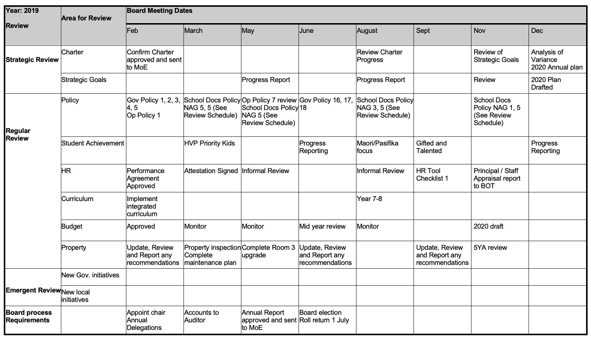

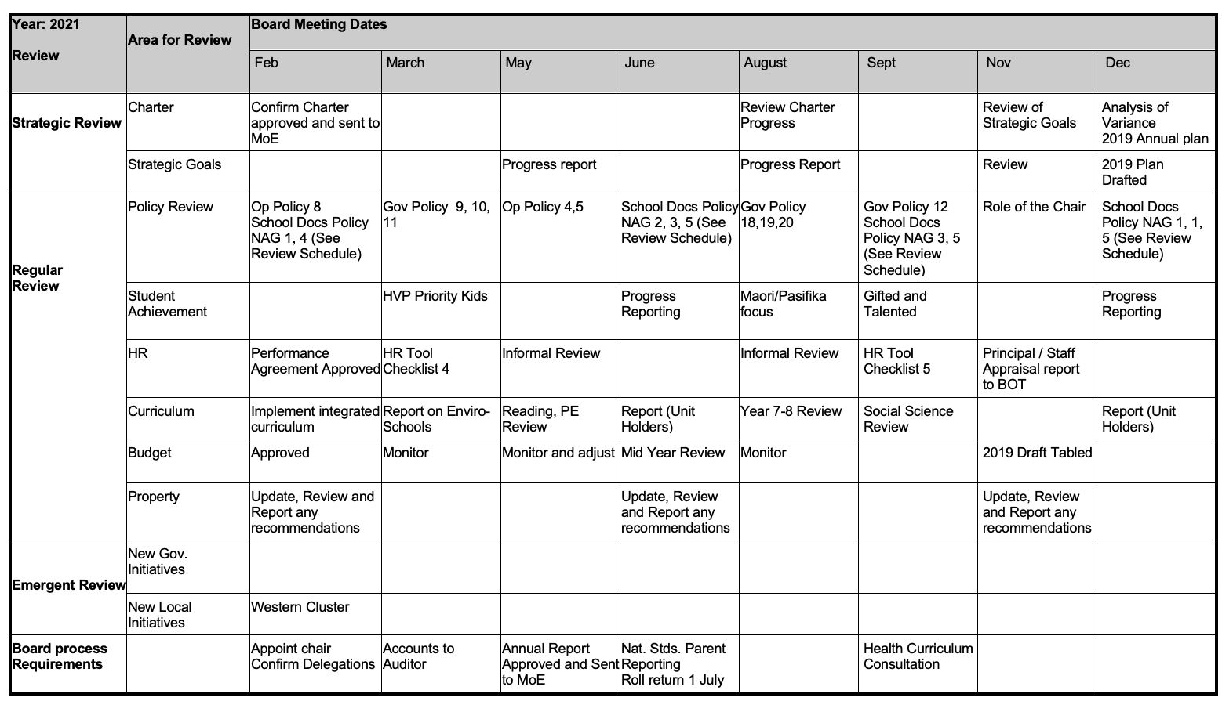

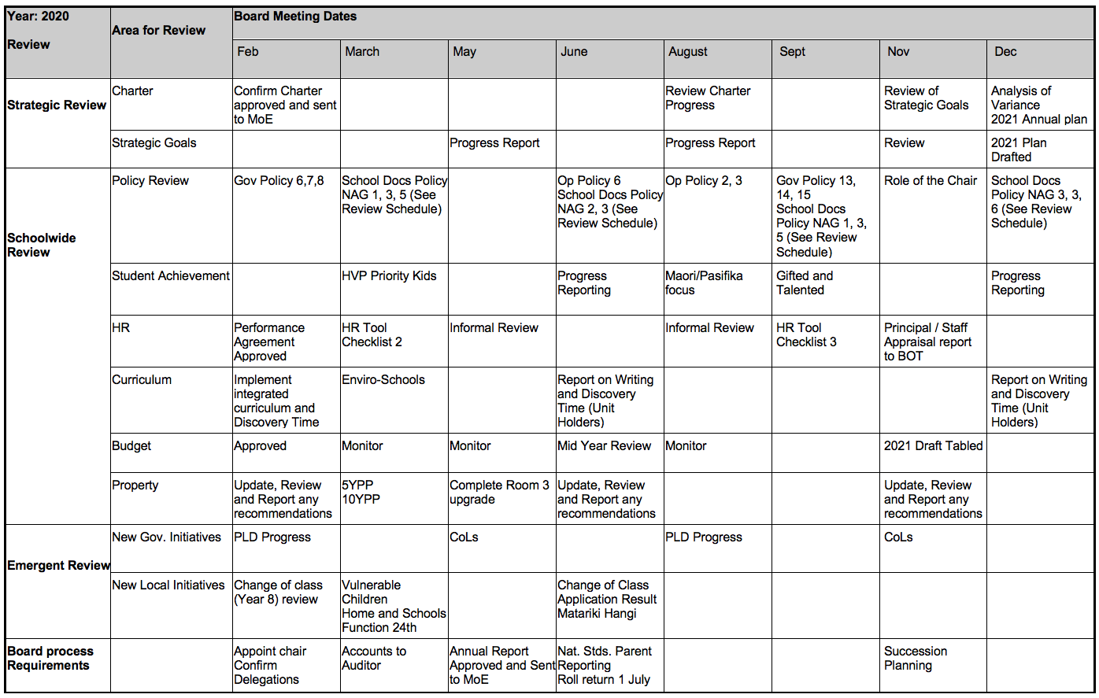
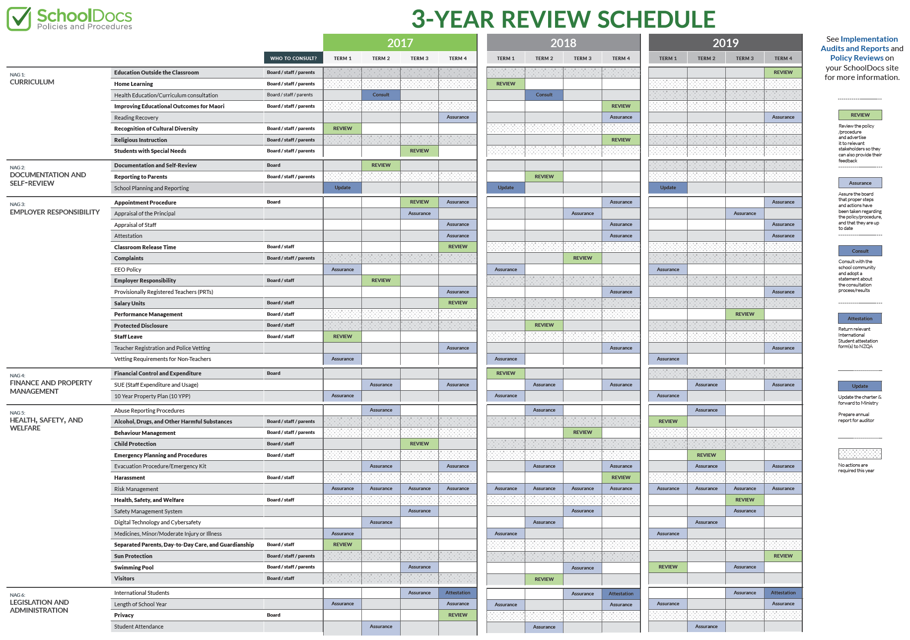

Part 3 Operational Policy
1. Curriculum Delivery Policy

Delivery of the curriculum shall foster student progress and achievement and meet all board expectations and legislative requirements. Therefore the principal must ensure:

- achievement of the Charter aims and targets
- compliance with the National Administration Guidelines
- there is a focus on the national priority groups of Maori, Pasifika and students with special learning needs in school planning and reporting
- that board approval is sought before changes to the school curriculum requiring increased expenditure or significant changes to programmes or staffing are made

Review schedule: Triennially

2. Personnel Policy

The board delegates responsibility to the principal on all matters relating to the management of staff in the expectation that they will be managed in a sound, fair, and respectful manner in accordance with the current terms of employment documents and identified good practice. Therefore, the principal must ensure:

- that all employment related legislative requirements are applied
- all employees their rights to personal dignity and safety and ensure that matters are resolved in an appropriate and fair manner
- a smoke free environment is provided
- that employment records are maintained and that all employees have written employment agreements
- that performance agreements are established for all staff and that reviews are undertaken annually
- a suitable professional development programme, which takes into consideration the requirements of the strategic and annual plans, is provided as part of each employee’s performance agreement
- board approval is sought for any requests for discretionary staff leave with pay
- board approval is sought for any requests for discretionary staff leave without pay of longer than 4 days
- board approval is sought for any requests for staff travelling overseas on school business
- the board is advised of any staff absences longer than 3 school days
- the requirements of the Health and Safety in Employment Act 1992 are met
- Advice is sought as necessary from NZSTA advisors where employment issues arise

Review schedule: Triennially

3. Appointments Policy

To assist in the appointment of quality staff to any vacancy which may arise, appointment committees with expertise relevant to the vacancy, will be selected to carry out the appropriate appointment procedures. Therefore, the principal must ensure that they:

- determine the composition of the various appointment committees according to the schedule outlined below:

a. Appointment of the deputy-principal, head of departments/senior teachers will involve an appointment committee consisting of the principal, the board chair and a further trustee (should the board feel the need to include one).
b. Unless determined otherwise by the board, appointment of all other teachers, part time teachers, long term relieving teachers, and non teaching staff will be the responsibility of the principal in consultation with the board chair or delegate where deemed necessary.

Appointment of the principal is the responsibility of the board which will determine the process

Review schedule: Triennially

4. Financial Planning Policy

The board of trustees has overall responsibility for the financial management of the school but delegates the day-to-day management of the school’s finance’s and budget to the principal. The principal, in association with the Finance Committee, is responsible for recommending an annual operating and capital budget to the board within the timelines specified in the Finance Committee terms of reference.

Budgeting shall not fail to reflect the annual plan, risk financial jeopardy nor fail to show a generally acceptable level of foresight.

Thus the budget should:

- reflect the results sought by the board
- reflect the priorities as established by the board
- comply where the board’s requirement is for a balanced budget
- demonstrate an appropriate degree of conservatism in all estimates

Review schedule: Triennially

5. Financial Condition Policy

The financial viability of the school must be protected at all times. The board understands that the possibility of theft or fraud can not be entirely eliminated however the principal is required to show there are in place safeguards and robust, clear procedures to minimise the risk of either event.

Resource: Reference should be made to 5.4 of the Financial Information for Schools Handbook (FISH). Therefore, the principal must ensure that:

- unauthorised debt or liability is not incurred
- generally accepted accounting practices or principles are not violated
- tagged/committed funds are not used for purposes other than those approved
- more funds than have been allocated in the fiscal year are not spent without prior board approval
- all money owed to the school is collected in a timely manner
- timely payment to staff and other creditors is made
- unauthorised property is not sold or purchased
- all relevant government returns are completed on time
- no one person has complete authority over the school’s financial transactions
- when making any purchase:
- of over $500, comparative prices are sought
- of over $500 an adequate review on ongoing costs, value and reliability is undertaken
- of over $500 on a single item board approval is first sought
- effective systems are in place to meet the requirements of the payroll system

Review schedule: Triennially

6. Asset Protection Policy

Assets may not be unprotected, inadequately maintained or unnecessarily risked. The principal is delegated day to day responsibility for ensuring that the programming and funding of general maintenance of the school grounds, buildings, facilities and other assets occurs in order to provide a clean, safe, tidy and hygienic work and learning environment for students and staff. Accordingly, the principal must:

- all board assets are insured
- not allow unauthorised personnel or groups to handle funds or school property
- not subject plant and equipment to improper wear and tear or insufficient maintenance or inappropriate use
- maintain an up to date asset register for all items of furnishing, plant machinery, equipment, text and library books costing more than $500.00
- ensure the implementation of the 10 year property maintenance plan
- engage sufficient property maintenance staff for the school within budget limitations
- receive board approval for maintenance contracts over $5000 for any one contract
- conduct competitive tenders for all contracting
- protect intellectual property, information and files from loss or significant damage or unauthorised access or duplication
- not receive, process or disburse funds under controls that are insufficient to meet the board-appointed auditor’s standards
- not invest or hold operating capital in insecure accounts, or in non-interest bearing accounts except where necessary to facilitate ease in operational transactions

Review schedule: Triennially

7. Health and Safety Policy

Students and staff shall have a safe physical and emotional learning environment. Therefore, the principal must:
- take all reasonable steps to protect students, staff and visitors to the school from unsafe or unhealthy conditions or practices
- ensure that the staff code of conduct is implemented effectively
- ensure there is zero tolerance to bullying and that there are effective processes in place
- comply with the provisions of the Health and Safety in Employment Act 1992
- provide a smoke free environment
- ensure a risk analysis management system (RAMS) is carried out where and when appropriate
- seek approval for all overnight stays/camps attesting first to their compliance with (4) above
- consult with the community every two years regarding the health programme being delivered to students
- advise the board chair of any emergency situations as soon as possible

Review schedule: Triennially

8. Legal Responsibilities Policy

School procedures will meet the legislative statutes and regulations as set down in the appropriate Acts, Ministry of Education circulars and the Education Gazette.

Review schedule: Triennially

Under Review 2020

